**Private Adult ADHD &/or ASD screening assessment and**

**diagnosis.**

ADHD-ASD Norfolk and Different Minds UK are independent entities working in partnership with each other to provide the highest level of diagnosis and guidance to neurodiverse individuals. All ADHD-ASD Norfolk’s services are delivered by its partnering organisation Different Minds East Anglia LLP. The clinical team is multi-disciplined consisting of a GMC registered Psychiatrist, HCPC Psychologists, Psychotherapists and ADHD coaches/psycho educators and counsellors.

Every individual ADHD/ASD (Attention Deficit Hyperactivity Disorder and Autistic Spectrum Disorder) person is unique and experiences the world in their own way. As with many other aspects of human neurodiversity, such as autism, ADHD and ASD have long been framed largely in negative terms.

ADHD and ASD individuals may be to a greater or lesser extent, and with significant individual variability forgetful, absentminded, easily distracted and easily bored, have difficulty communicating with others or see and experience the world differently. Yet by focusing only on negatives as compared with neurotypical individuals, it is very easy for those not working with or educated in the complexities of neuro divergence to only focus on the negative aspects of neurodiversity and not see the positive aspects, such as out of the box thinking, an ability to think abstractly to name just one or two.

**Steps to screening and full diagnosis.**

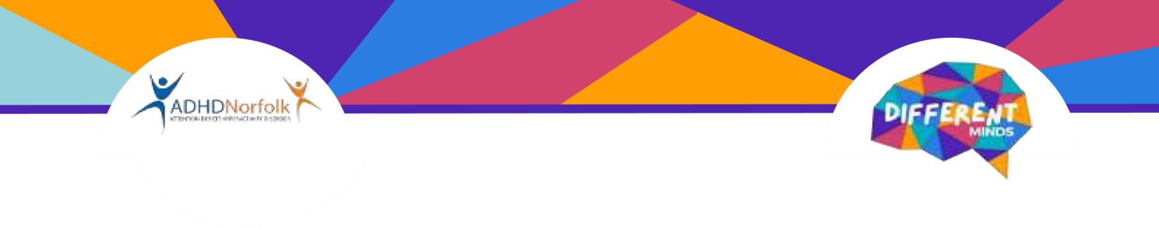

1. E-mail **enquiries@adhdnorfolk.org.uk** to book a consultation for your initial screening, at the screening we will screen for both Attention Deficit Hyperactivity Disorder and Autism Spectrum Disorder (ADHD & ASD). If you are unsure that ADHD or ASD is presenting please contact us for a telephone consultation where we can talk to you and guide you before you book a consultation.

**Screenings for Adults are available either in clinic or via Zoom.**

1. Once you have undertaken the screening, a consultation outcome report will be sent to you within 21 working days, this may be delayed if you have not provided all the documentation we ask for at the time of the screening. If you do not provide all documentation requested within 1 month of your assessment an additional fee may be charged to retrieve your documentation and review your file after this date.

1. If you meet diagnostic criteria and would like to progress to a full formal diagnosis after you have received the screening outcome, please email and request a full diagnosis consultation. The diagnosis will be undertaken and led by a GMC registered psychiatrist as part of a multi-disciplinary team. After your full diagnosis we will write to your GP and advise them of the formal ADHD or ASD diagnosis, we also send you a copy of the diagnosis letter to you for you to present to your university or an employer should you wish.

1. **Adults (17 years of age or over).** We will undertake a full formal diagnosis for you however we do not medicate adults with stimulant medication. We only prescribe Atomoxetine a non-stimulant ADHD medication.

Once you have a full diagnosis you should ask your GP if they would kindly refer you to the adult NHS ADHD pathway should you decide that you would like to trial stimulant medication. We will only prescribe Atomoxetine a non-stimulant ADHD medication, we will not prescribe stimulant medication. Please note you will be responsible for purchasing any medication prescribed from a normal pharmacy, we will provide you with a private prescription.

One year of medication reviews for ADHD medication is included in the diagnosis fee. If you require medication reviews and prescriptions after year one, a fee of £200 per year for the following year will be payable

1. **Professional fees.**

* + **ADHD & ASD screening** and report £375.00 payable at the time of booking. Screening can be undertaken wither in clinic or by Zoom.

* + **ADHD full diagnosis** after screening £750.00 payable at the time of booking.

* + **ASD full diagnosis** after screening (2 further consultations ADI-R, ADOS-2 and ABAS3 document for completion) and comprehensive report £1500.00. Please note that some appointments may be recorded.

# • ADHD coaching/counselling/psychoeducation

We offer coaching and psychoeducation sessions for ADHD & ASD in the clinic for individuals, couples and families, the cost per session is £95.00. We also offer coaching for individuals at their school, travel charges may be added to the coaching fee. Access to work coaching fees are £105.00 per session

1. All ADHD-ASD Norfolk’s services are delivered by Different Minds East Anglia, our multidisciplinary team consists of a GMC registered psychiatrist, psychologists, psychotherapists, ADHD/ASD coaches and counsellors. Our clinic can also offer access to work packages to assist adults within the workplace.

1. We diagnose in line with ICD-11 and DSM-V guidance criteria.

1. NICE NG87 refers to the National Institute for Health and Care Excellence guidelines on Attention Deficit Hyperactivity Disorder (ADHD) in children, young people, and adults. Specifically, NG87 emphasises the importance of considering ADHD behaviours across two domains.

In the home setting, NICE recommends that healthcare professionals assess ADHD behaviours within the family environment. This includes understanding how symptoms manifest in day-to-day activities, interactions with family members, and the overall impact on familial relationships and functioning. Assessing ADHD within the home domain allows for a comprehensive understanding of the individual's behaviour in a more relaxed and informal context.

Simultaneously, NICE underscores the significance of evaluating ADHD behaviours in a second domain within the work or educational setting or elsewhere. This involves examining the individual's performance, interactions with peers and teachers/lecturers/work colleagues, and any challenges faced in academic and non-academic activities. Assessing ADHD in both home, education and other environments provides a holistic perspective, ensuring that the diagnosis and subsequent interventions are tailored to the individual's needs across different aspects of their life.

We will ask that you provide documentation to us for review at the screening, these documents will be sent to you for completion once an appointment has been booked for the screening. Please bring in all documentation requested to the screening with you.

1. To assist in alleviating ADHD symptoms physical exercise should be increased and alcohol/recreational narcotics reduced or eliminated. Sugar should also be reduced as far as practicably achievable from your diet.

1. Once you have your appointment confirmed and payment has been made any cancellations made within 96 working hours of your appointment or failure to attend the clinic at the appointed day and time, will be chargeable in full. Unfortunately, we are unable to fill appointments cancelled at short notice. Rescheduling a booked appointment within four weeks of the booked date will incur a fee of £150.

1. Booking a screening appointment confirms that you agree to the terms as set out in this document irrespective of you signing the document, and that all and any documentation given to us by you to assist in the screening and diagnosis, and any information given by you at the screening and diagnosis will be accurate and true.

**Please do not make any appointments with us for ADHD or ASD screening, coaching or diagnosis until you have read this document in full, understand the document and agree to its terms and conditions. Once read and agreed please sign and bring it to your screening consultation.**

**I have read and agree to the above;**

**Name: ________________________________**

**Mobile No: _____________________________**

**Signed: ________________________________ Date _____/____/_____**

# E.mail: ________________________________________________________

**How to find us.**

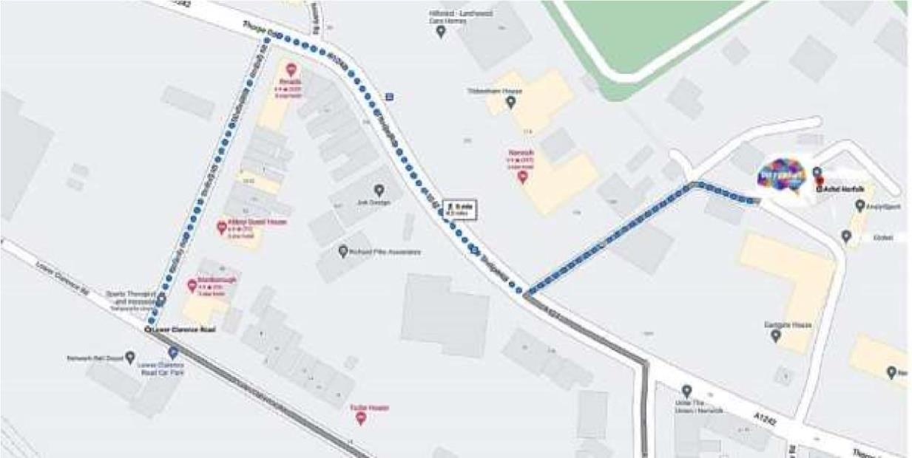

**Important:**

**Parking is not available at the clinic.**

# Parking is available on Stracey Road, Limited spaces on Cotman Road or at lower Clarence Road pay and display car park, 5 mins walk away. Alternatively,

**Morrisons riverside car park is free for 2 hours and is a 10 min walk to us.**